Brainstorming and Idea Prioritisation Template
Incident Lifecycle Automation in ServiceNow

1. Purpose
This template supports structured brainstorming and comparison of possible solutions for improving IT incident management in ServiceNow. It helps the project team identify useful ideas, evaluate their value, and select a practical approach for further analysis.

2. Problem area
IT incidents can be delayed or inconsistently handled when assignment, communication, knowledge reuse, and resolution tracking rely heavily on manual effort. The project explores how ServiceNow capabilities may help make the incident lifecycle more consistent and traceable.

3. Brainstorming prompts
- How can an incident be recorded with the information needed for support?
- How can incidents be categorized and prioritised consistently?
- How can incidents reach the appropriate support group more efficiently?
- How can users and support teams receive timely status updates?
- How can Knowledge Management help technicians reuse known solutions?
- How can incident records and resolution details support follow-up analysis?
- How can a related change be handled through the appropriate Change Management process when required?

4. Idea capture template
Use the blank table below to record ideas during a brainstorming session. Add rows as needed.

5. Idea prioritisation method
Score each idea from 1 (low) to 5 (high) for each criterion. Suggested criteria are user benefit, feasibility in ServiceNow, potential time savings, and alignment with the project scope. Multiply each score by its weight if weighted scoring is required. Scores are preliminary and should be validated during requirements analysis.

6. Suggested prioritisation criteria
User benefit — Does the idea make incident handling clearer or easier?
Feasibility — Can the idea reasonably be configured using available ServiceNow features and access?
Efficiency — Could it reduce repetitive manual steps or avoidable delays?
Scope fit — Does it directly support incident creation, assignment, tracking, resolution, or closure?

7. Initial candidate ideas
Standardise incident fields and categorisation.
Define a consistent approach for priority using impact and urgency.
Explore Flow Designer for appropriate notifications or assignment steps.
Use Business Rules where server-side record logic is needed.
Make relevant Knowledge articles easier for support staff to find.
Document how a related change is raised and managed when an incident requires a system change.
Use clear resolution notes and closure information.

8. Decision and next steps
Selected idea(s):
Reason for selection:
Assumptions to validate:
Next step: Validate the selected ideas against stakeholder needs, platform capabilities, access permissions, and project requirements.

Idea capture
ID | Idea | Expected benefit | Effort / dependency | Notes
IDEA-01 | IDEA-01 | Consistent prioritization | Medium; ServiceNow configuration and testing | Recommended for initial implementation
IDEA-02 | IDEA-02 | Faster routing | Medium; ServiceNow configuration and testing | Recommended for initial implementation
IDEA-03 | IDEA-03 | Fewer missed SLA deadlines | Medium; ServiceNow configuration and testing | Recommended for initial implementation
IDEA-04 | IDEA-04 | Faster resolution | Medium; ServiceNow configuration and testing | Recommended for initial implementation
IDEA-05 | IDEA-05 | Better data quality | Medium; ServiceNow configuration and testing | Recommended for initial implementation

Prioritisation score (1 = low, 5 = high)
Idea | User benefit | Feasibility | Efficiency | Scope fit | Total
IDEA-01 | Consistent prioritization | 4/5 | 5/5 | 5/5 | 19/20
IDEA-02 | Faster routing | 4/5 | 5/5 | 5/5 | 19/20
IDEA-03 | Fewer missed SLA deadlines | 4/5 | 5/5 | 5/5 | 19/20
IDEA-04 | Faster resolution | 4/5 | 5/5 | 5/5 | 19/20
IDEA-05 | Better data quality | 4/5 | 5/5 | 5/5 | 19/20

Process Diagram
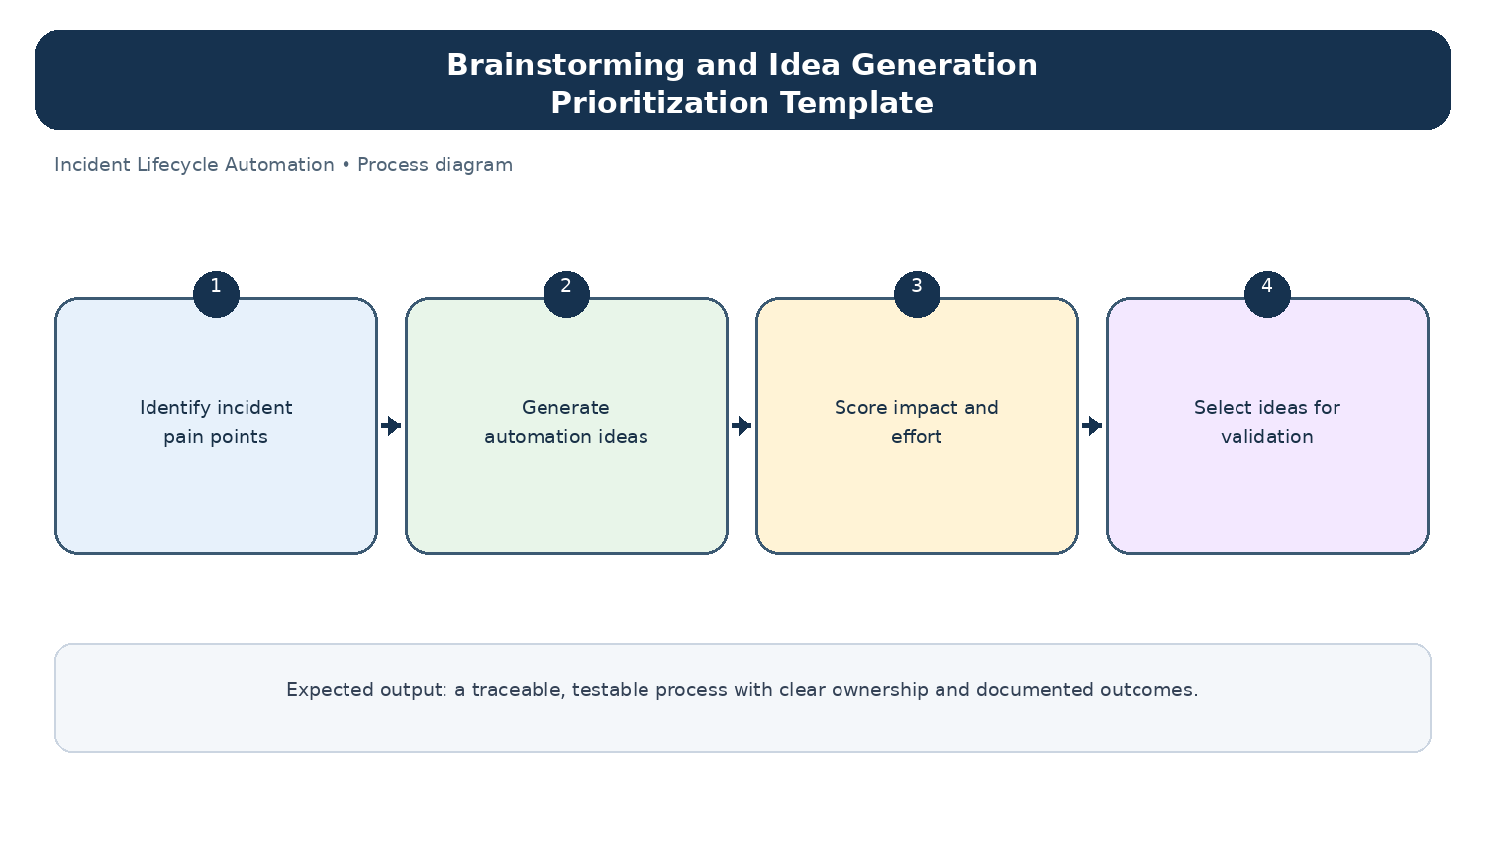
Diagram: Brainstorming and Idea Generation Prioritization Template — project-specific process overview.

